UI AND UX DESIGNING
UI:
User interface means how a product looks
UX:
User experience means how the user feels while using a product
UI INCLUDES:
1. Buttons
2. Icons
3. Colour
4. Fonts
5. Layouts
6. Menus
7. screens
UX INCLUDES:
1. Easy to use or not
2. Smooth navigation
3. User satisfaction
4. Speed
5. Comfort
DIFFERENCE BETWEEN UI AND UX:
UI UX
1) Focuses on look 1) focuses on experience
2) Colours, fonts, buttons so on 2) user journey and useability
3) Visible design 3) functional design
UI DESIGNER ROLE:
1) Design attractive screens
2) Choose colours and fonts
3) Create layouts
UX DESIGNER ROLE:
1) Understand user needs
2) Create user flow
3) Improve usability
Ex: 1) a beautiful app is the good UI
2) An easy – to- use app good UX.
COMMON UI AND UX TOOLS:
1) Figma
2) Adobe XD
3) Sketch
4) Invision
Project 1:
TITLE: Create a proper mobile app screen [Frame]
Purpose: Every app starts with screen. This is not drawing freely. It must match real devices.
Process:
1) Open Figma [web version]
2) Click new design file
3) Press f [Frame tool]
4) From right panel → choose Android → pixel 7 (or) iPhone 14
Output:
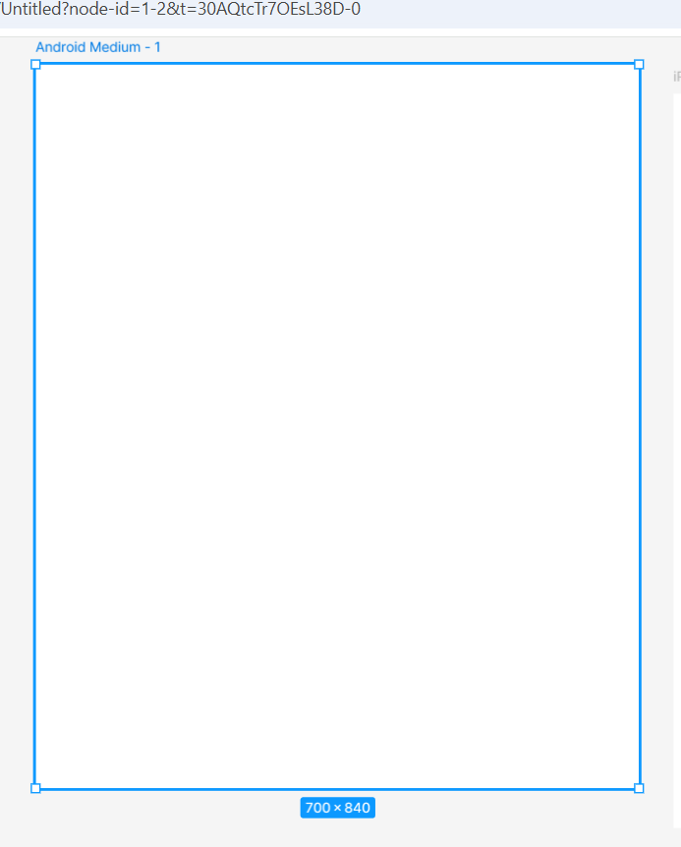
Project 2:
TITLE: create an app header with title text “Food Delivery”.
Purpose: Every app need identifier and visual .
Process:
1) Press t [text tool]
2) Click near top of the frame
3) Type “food Delivery”
4) Font size 24
5) Foot weight semi bold
6) Align centre
7) Text colour blue
Output:

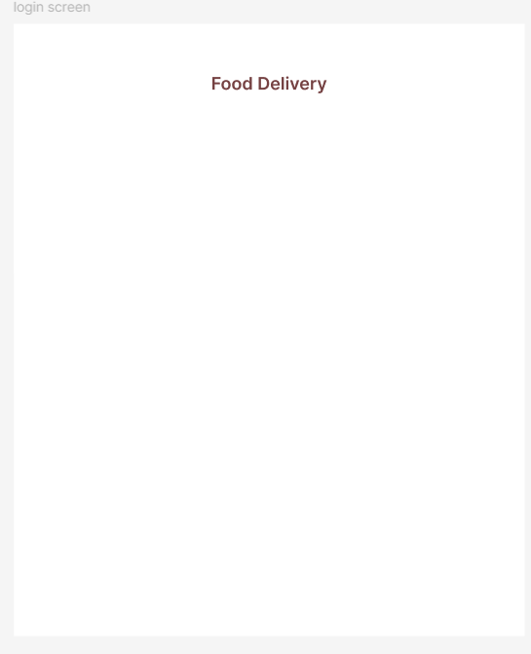
Project 3:
TITLE: section divider
Purpose: to separate header and form content clearly.
Process:
1) Press R
2) Draw a thin rectangle below title
3) Height 1
4) Width 80% of screen
5) Colour Red
6) Align centre
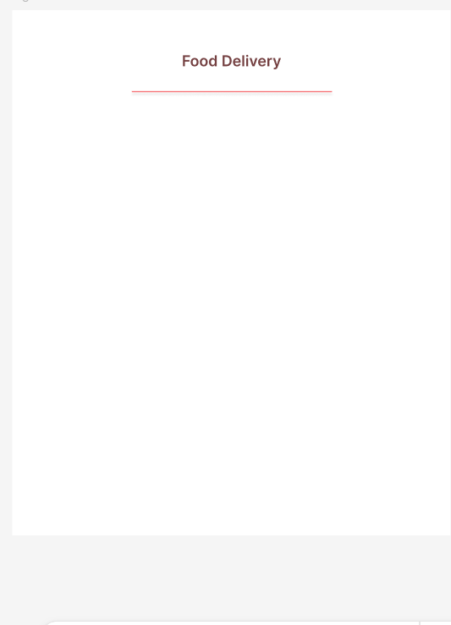
Project 4:
TITLE: create a form label with email address
Purpose: user should know what to enter even before typing.
Process:
1) Press t
2) Below divider →type email address
3) Font size 13
4) Colour medium grey
5) Keep left align
Project 5:
TITLE: Create an input field with boarder and radius
Purpose: This represents user interaction area
Process:
1) Press r
2) Draw rectangle below label
3) Height 44
4) Fill white
5) Stroke light grey border
6) Corner radius 8
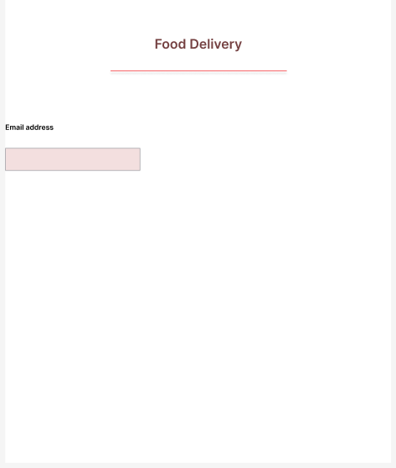

Project 6:
TITLE: Create a placeholder text inside input box
Purpose: Guide user what format to type
Process:
1) Press t
2) Click inside input box
3) Type enter your email
4) Font size 13
5) Colour light grey
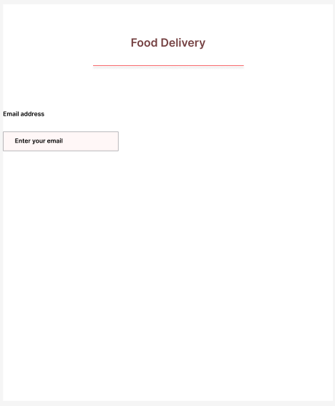

Project 7:
TITLE: Create a form label with password field
Purpose: Consistency saves time and improve UI quality
Process: 1 Create password: place a place holder in that write “enter your password”
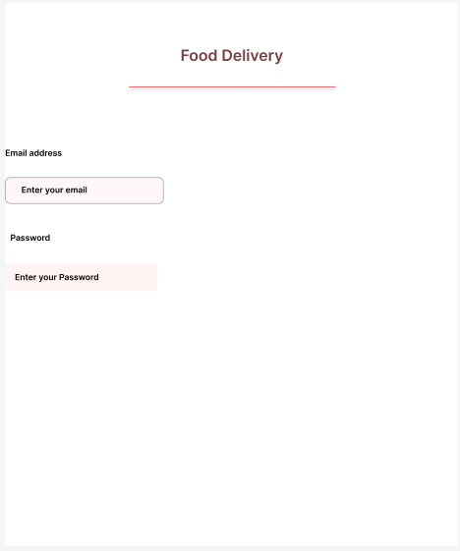

Project 8:
Title: Create forgot password
Purpose: To change the forgot password
Process:
1. Press T
2. Type forgot password?
3. Set right alignment
4. Stroke black
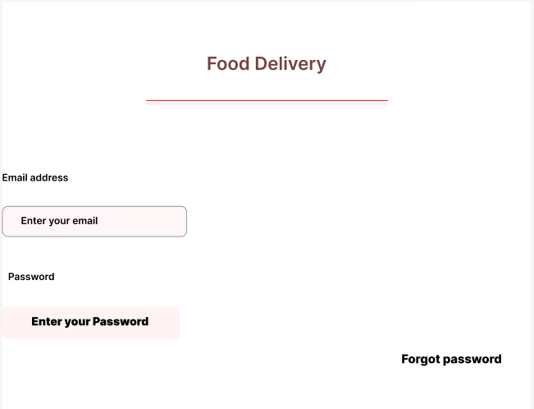
Project 9:
Title: Creation of login button secondary action
Purpose: To enter their verified credentials.
Process:
1. Press R
2. Set height 3
3. Set centre alignment
4. Stroke colour blue
5. Press T
6. Type login and font size 16
7. Text colour white and align centre
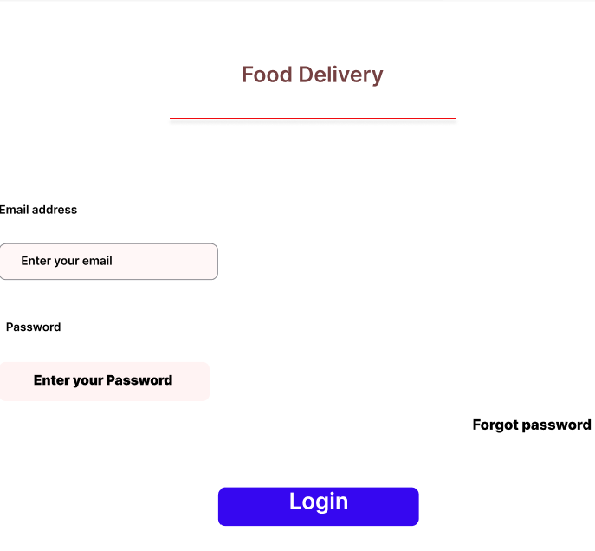
Project 10:
Title: Creation of OR divider
Purpose: Multiple login options without confusion
Process
1. Press T
2. Type OR and set centre alignment
3. Stroke colour black
4. Press R
5. Height 1 and set right alignment
6. Press R
7. Height 1 and set left alignment
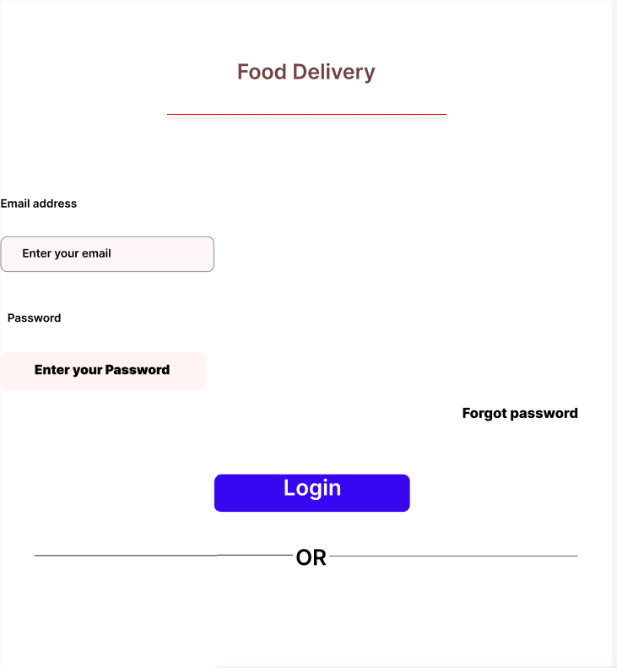
Project 11:
Title: Creation of account creation prompt ( sign-up link) secondary CTA
Purpose: User sign up to
Process:
1. Press T
2. Below the divider type don’t have an account?
3. Sign up
4. Size 40
5. Sign up blue colour
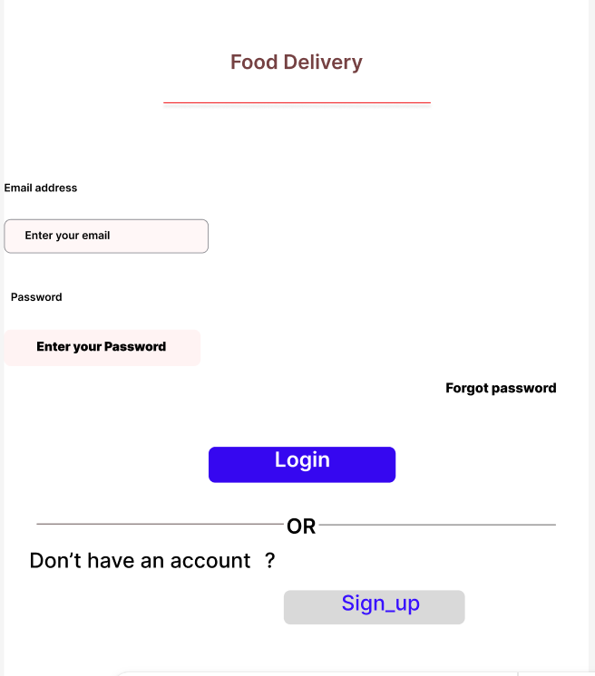
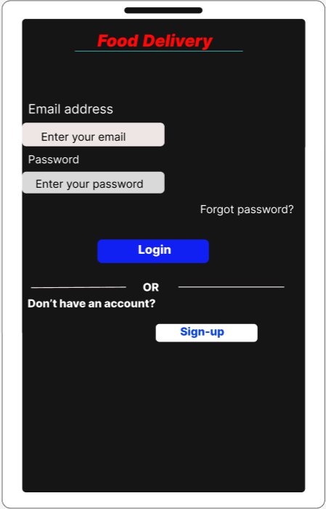

Project 12:
Title: Creation of Group and Duplicate UI Elements
Process:
- Hold shift and click on each element one by one
    - This selects multiple elements
- Press ctrl + G
    - The selected elements are grouped.
- You will see a group name appears in the layers panel
- Select the group, then press ctrl + D
- A new copied group appears in the layers panel
- Drag the copied group to the required position on the canvas
- Output:
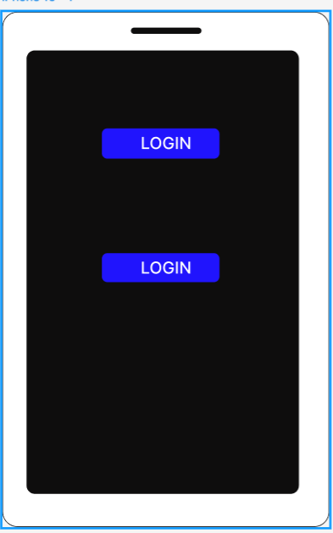

Project 13:
Title: Insertion of an Image Inside a Shape
Process:
- Draw a rectangle (R)
- Select the rectangle
- In right panel
- Click colour to change the image
- Click choose image
- Select image
- Image fits inside the shape
Output:


Project 14:
Title: Insertion of an Image using the Place Image Tool
Process:
- Press Shift + ctrl + K(Windows)
- Select the image from your computer
- Click Open
- Click anywhere on the canvas
- Image gets placed
Output:


Project 15:
Title: Inserting of Social Media Icons in Figma Using Iconify
Process:
- Open your Figma file
- Right-click on the canvas
- Search and install iconify
- Run the plugin: 1.Right-click 2. Plugins 3. Iconify 4. Run
- Search for each icon: Facebook, Twitter, Instagram, Google etc.
- Click the icon
- Position them where you want.
Output:



